RECOGNIZING PUBLIC HEALTH HEROES WORKING TIRELESSLY
BEHIND THE SCENES TO KEEP COMMUNITIES HEALTHY AND SAFE

Dear Public Health Hero,
You have been identified as one of the valuable #PublicHealthHeroes championing important work to keep our communities safe and healthy during Covid-19 and beyond in your day-to-day public health role.
The Ontario Public Health Association (OPHA) would like to thank you for the service you provide to the community and recognize you in our #PublicHealthHeroes campaign.
The campaign aims to call attention to the important work our public health sector is doing behind the scenes to save lives, promote health, and advance health equity. The campaign also aims to increase the profile of public health and showcase its value during this defining time, for the purpose of increasing public and political support for strengthened public health structures. We intend to do this by:
- increasing the profile of the public health sector by growing awareness of what it does for the public, and;
- celebrating its behind the scenes work and effectiveness during Covid-19
If you agree to participate in this campaign as a featured Public Health Hero, your profile will be featured on the OPHA website in a “gallery of heroes”, and be showcased along with other profiles though social media and other promotional activities.
To be considered as a Public Health Hero in this campaign, please complete the attached template and submit to MSanderson@opha.on.ca along with this signed form granting OPHA permission to use your information for the activities outlined above.
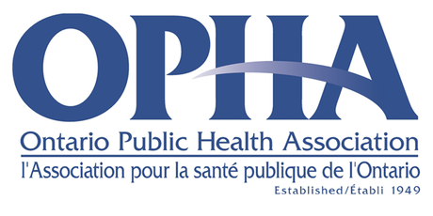
Thank you for your consideration and for the tireless work that you are doing to keep your community safe and healthy.
Sincerely,
The Ontario Public Health Association Team

Permission:
I ____(first name and last name)_______________________________ grant OPHA permission to use my Public Health Hero Template information provided for the activities outlined above in the #PublicHealthHeroes campaign.
Date: ________________________ | Signature: ___________________

Tips for including a photo:
You can insert a photo directly into the Public Health Hero template or paste one here for our team to insert it to the template for you. Photos don’t need to be diamond shaped (like the example in the template). We may crop it to fit the shape if appropriate, or include your photo as a different shape given the size and dimensions.
Please ensure photo is high resolution, and that there are no other individuals in the photo. If you are able to snap a picture of you in action in your public health role, this is even better!

Link to the Template:

About OPHA
Created in 1949, the Ontario Public Health Association (OPHA) is a non-partisan, non-profit organization that brings together a broad spectrum of groups and individuals concerned about people’s health. OPHA’s members come from various backgrounds and sectors - from various disciplines in public health, health care, academic, non-profit to the private sector. Members are united by OPHA’s mission of providing leadership on issues affecting the public’s health and strengthening the impact of people who are active in public and community health throughout Ontario. This mission is achieved through professional development, information and analysis on issues effecting community and public health, access to multidisciplinary networks, advocacy on health public policy and the provision of expertise and consultation.

